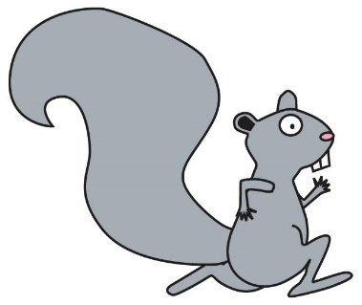
JIMMY KENNEDY MEMORIAL RUN TO CURE ALS
AKA SQUIRREL RUN XXV

Gold Sponsor / $1,000
- Placement of company logo on Squirrel Run t-shirt
- Booth space at race
- Company logo in e-newsletter and social media
- Prominent placement of company name in press releases
- Company logo on Squirrel Run page on website
- Company logo on banner at the race
- Verbal acknowledgment at the race

Silver Sponsor / $500
- Company name mentioned in press releases
- Company logo in e-newsletter and social media
- Company logo on Squirrel Run page on website
- Company logo on banner at the race
- Verbal acknowledgment at the race

Bronze Sponsor / $250
- Company logo on website
- Company logo in e-newsletter
- Company logo on banner at the race
- Verbal acknowledgment at the race
Friend Sponsor / $100
- Verbal acknowledgement at race
Yes, I would like to become a sponsor of the Squirrel Run. q GOLD q SILVER q BRONZE q FRIEND
COMPANY NAME:__________________________________________________________________________
CONTACT: ____________________________________________PHONE:_____________________________
ADDRESS: ________________________________________________________________________________
CITY:_________________________________________________STATE:______________ZIP:_____________
Please make check payable to: The Angel Fund for ALS Research and mail to: 649 Main Street, Wakefield, MA 01880
THE ANGEL FUND FOR ALS RESEARCH - 649 MAIN ST., WAKEFIELD, MA 01880 - WWW.THEANGELFUND.ORG - 781-245-7070

