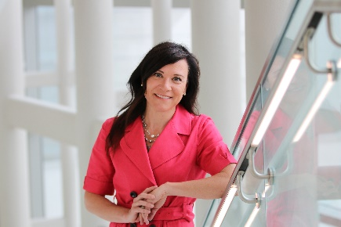
Daryl A. Bosco, PhD
Professor of Neurology
Dr. Bosco earned her Ph.D. (bio-organic chemistry) in 2003 from Brandeis University, where she used NMR spectroscopy to study enzyme dynamics, and was then a post-doctoral fellow in the lab of Jeffery W. Kelly at the Scripps Research Institute, studying misfolding of a Parkinson’s disease-associated protein. Prior to joining the faculty at UMMS in 2008, Dr. Bosco was an Instructor of Neurology at Harvard Medical School working with Dr. Robert H. Brown, Jr. on various aspects of ALS. Currently, the Bosco laboratory at UMass Chan Medical School is investigating the mechanisms underlying ALS using a multidisciplinary approach involving protein biochemistry, structural biology, human stem cell technology (to generate human motor neurons and human microglia) and ALS mouse models. The ultimate goal of this research is to understand the factors that trigger and perpetuate ALS, and to translate these findings into therapies for ALS.

