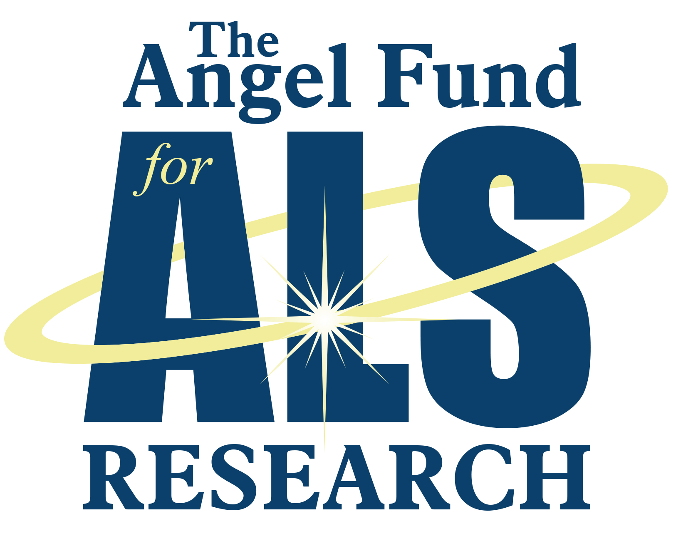

Research Update 23-November-2020
The Angel Fund for ALS Research
By Dr. Robert H. Brown, Jr.

It is a pleasure to provide this year end research update on the Angel Fund’s ALS research program at UMass Medical School, which continues along several fronts.
- First, we are continuing our investigations of the compound we call afinersen for ALS arising from mutations in the C9orf72 gene. This compound, an antisense oligonucleotide (ASO), has continued to look promising in the initial pilot trials in a single individual. We have engaged the FDA regarding opportunities to expand our trial; these efforts are underway.
- Second, we are continuing to pursue our program to suppress the SOD1 gene using a different type of compound, known as a microRNA, delivered into the spinal fluid using an adeno-associated virus (AAV). Some aspects of this program are being studied in detail in our laboratories; at the same time, an expanded human trial is being planned by a company (ApicBio) in Cambridge. Our initial report of our pilot study of this modality was published as a Brief Report in the New England Journal of Medicine last summer (Mueller CM et al., New Engl J Medicine, 383(2):151-158). It is particularly exciting that in the same issue, the Cambridge company, Biogen, reported that an ASO that they are investigating, called tofersen, suppresses SOD1 gene in many patients with SOD1 gene mutations.
- Third, in parallel studies we have explored the use of an ASO to suppress the ALS gene known as FUS, which unfortunately often causes devastatingly rapid ALS in young adults (and even children). We have been deeply grateful in this project initially to work with a California company (Ionis) with expertise in this area. We have extensively tested an ASO from Ionis that suppresses the FUS gene effectively in patient motor neurons in culture. A collaborator in the program, Dr. Neil Shneider at Columbia University, has now used this anti-FUS ASO in pilot studies in several FUS patients.

In parallel with these trials focusing on human therapies, we continue to work in preclinical therapy development in the laboratory. We have been privileged to study a compound from a German pharmaceutical company in our SOD1 mouse model. This exciting project is a collaboration with investigators in Chile (Dr. Brigitte van Zundert) and Barcelona (Dr. Xavier Navarro Acebes). Our three-arm consortium has accelerated the testing of this drug by exploring its different aspects in our three laboratories, in parallel. In another project, one of the foremost investigators at UMass Medical School, Dr. Anastasia Khvorova (RNA Therapeutic Institute at UMMS), has developed a new type of ASO, with novel chemical properties that originated in her laboratory. We are working closely with Dr. Khvorova and her team to determine how effectively these innovative new ASOs can permeate the brain and spinal cord and then suppress potentially toxic ALS genes.

Beyond these projects that focus on therapy development, we have continued some lines of more basic investigations related to the causes of familial and sporadic ALS. A very exciting program, pursued with collaboration with Dr. Paul Greer (Program in Molecular Medicine, UMMS) has been to closely study the diversity of cell types in the brain and spinal cords of ALS mice to define which cells are first afflicted by the disease and the nature of the abnormalities in each cell type across the time course of the disease. This approach employs a remarkable new technique that analyzes thousands of genes in each of thousands of cells from each specimen studied. We believe this method will define elements of ALS pathology that are common to both familial and non-familial forms and thereby illuminate further targets for therapy. In this single cell sequencing project we have been fortunate to work with a very talented and committed graduate study, Kathleen Mocarski. A second very basic, preclinical program in the laboratory involves a detailed analysis of how mutations in ALS genes influence the folding of chromosomes both in close proximity to the mutant genes and beyond. This work is the doctoral project for Ozgun Uyan, who is co-sponsored by Dr. Job Dekker, an internationally recognized expert in DNA and chromosome folding. Through Dr. Dekker’s expertise, Ozgun has been able to gain insights both into the basic chromosomal folding process in normal motor neurons, and the ways in which this folding is perturbed by mutations in ALS genes.

Let me conclude with three other general points.
- First, in addition to the above projects, there multiple other highly productive investigations at UMMS related to ALS or frontotemporal dementia, which is closely related. These are directed by many of our outstanding colleagues including Profs. Fen-Biao Gao, John Landers, Daryl Bosco, Zuoshang Xu, Larry Hayward, Nils Henninger and others. We will review the full constellation of these projects in a subsequent report.
- Second, this has been an extraordinary season for progress in ALS therapies. In addition to the two reports noted above, the New England Journal also published a report of efficacy in the combination drug therapy produced by Amylyx in Cambridge. This therapy, a powder taken by mouth, was shown to be safe and to both slow the course of the disease and prolong survival.
- Third, and finally, the pipeline of drugs to be tested in ALS is quite full and the modalities for testing them is greatly improving (for example, by the platform trial design initiated by the Healey Center, involving scores of ALS teams across the country). For all of these reasons, there is immense hope that additional, clinically meaningful ALS treatments are coming. We are deeply grateful to the Angel Fund for its most generous, ongoing support in the quest for ALS treatments.

